O DWELLERS OF MY PARADISE!
With the hands of loving-kindness I have planted in the holy garden of paradise the young tree of your love and friendship, and have watered it with the goodly showers of My tender grace; now that the hour of its fruiting is come, strive that it may be protected, and be not consumed with the flame of desire and passion.
--Bahá’u’lláh
I beseech you, one and all, to add your prayers to mine to the end that war and bloodshed may cease, and that love, friendship, peace and unity may reign in the world.

--Abdu'l-Baha


O Lord! Draw up the people from the abyss of the ocean of hatred and enmity, and deliver them from the impenetrable darkness. Unite their hearts,
and brighten their eyes with the light
of peace and reconciliation.

--Abdu’l-Baha

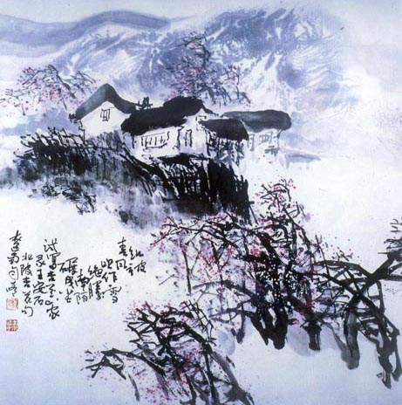

Put into practice the Teaching of Bahá'u'lláh, that of kindness to all nations. Do not be content with showing friendship in words alone, let your heart burn with loving kindness for all who may cross your path.

--Abdu'l-Baha

Who finds a faithful friend, finds a treasure.
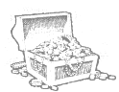
-- Jewish Saying

What profit is there in agreeing that universal friendship is good, and talking of the solidarity of the human race as a grand ideal? Unless these thoughts are translated into the world of action, they are useless.

The wrong in the world continues to exist just because people talk only of their ideals, and do not strive to put them into practice. If actions took the place of words, the world's misery would very soon be changed into comfort.

--Abdu'l-Baha

"One loyal friend is worth ten thousand relatives."
-- Euripides (408 B.C.)

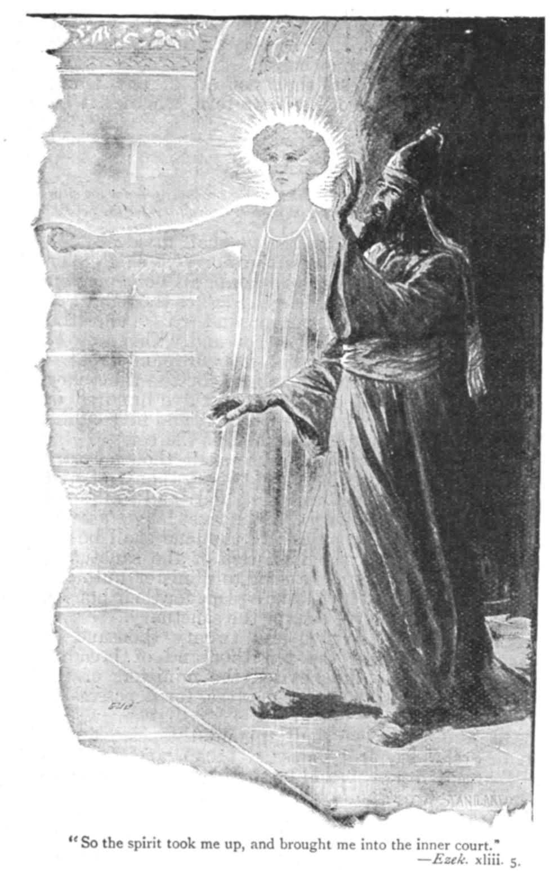
"Let there be no purpose in friendship save the
deepening of the spirit."
-- Kahil Gibran.

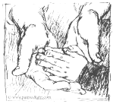
Hold a true friend with both your hands.

-- Nigerian Proverb

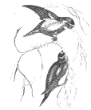
"A friend loves at all times."
-- The Bible: Proverbs 17, 17.

Seeing a Friend Off

Green mountains range beyond the northen wall.
White water rushes round the eastern town.
Right here is where, alone and restless, he
Begins a journey of a thousand miles.

While travelers' intents are fleeting clouds,
A friend's affection is a setting sun.
He waves good-bye, and as he goes from here,
His dappled horse lets out a lonely neigh.


--Li Bai

